Semaphore Short Friday 20 March 2026

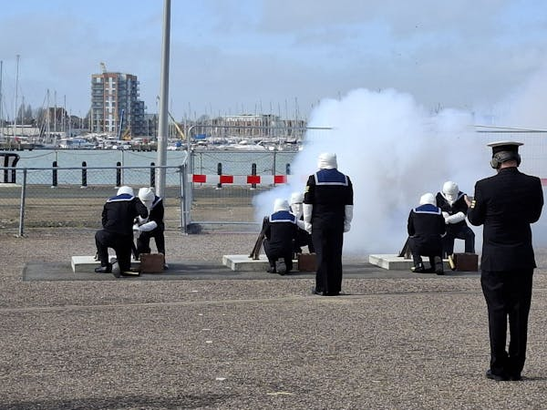

Admiral of the Fleet Sir Benjamin Bathurst honoured

The Royal Navy honoured the memory of Admiral of the Fleet Sir Benjamin Bathurst GCB, DL with a 19-gun salute at Portsmouth Naval Base on Tuesday 17 March.
The Admiral, who died on 12 October last year at the age of 89, served more than 40 years in the Navy, commanding two ships and holding a number of senior positions, including First Sea Lord (1993-95) and Vice Chief of Defence Staff.
The salute coincided with a memorial service for the officer at St Margaret’s Church, Westminster Abbey.
For a full report see the News section of the RNA website (click here) or see the April edition of the Semaphore Circular.

Soldiering On deadline

Nominations for the X-Forces Enterprise (XFE) 2026 Armed Forces Community Awards – formerly known as the Soldiering On Awards – close on 29 March.
The awards are a national platform that celebrates the exceptional achievements of the Armed Forces community, not just on one night, but throughout the year.

Across 12 categories, the awards honour individuals, teams and organisations, including serving personnel, veterans, families, and those who support them.
Judging takes place in April and May, with the finalists in each category being announced on 22 June. There will be a reception for finalists at the House of Lords on 15 July, and winners will be announced on 17 September.
Full details of categories and how to nominate can be found at https://www.soldieringon.org

  RNA survey offers prize incentive
  Do you have a few minutes to spare to help us help you and your shipmates? Your response could be worth £100…
  It will only take a few minutes to complete the RNA 2026 Membership Survey, which will enable us to understand all members’ views on the RNA and its activities.
  And for one lucky entrant, drawn at random, there will be a £100 Amazon gift voucher. Click HERE or scan the QR code
  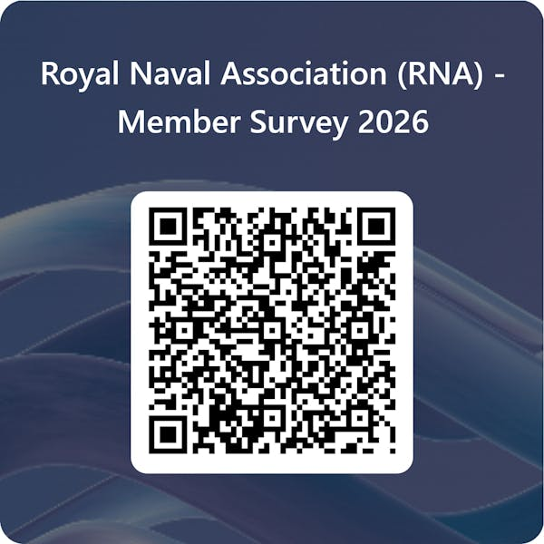

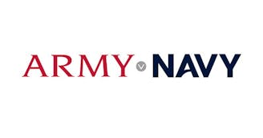
Army v Navy tickets re-released
A limited number of tickets in the RNA section of Twickenham for the Army v Navy rugby clash on Saturday 2 May have been released today.
The tickets were ordered but never paid for, so have been released for RNA members who would like to attend this grand day out.
Please click HERE to reserve yours!

  The annual RNA Standard Bearers Competition and training is due to take place on 8 and 9 May at HMS Collingwood in Fareham, Hampshire.
  Anyone wishing to participate should contact both the National Ceremonial Adviser, S/M Mike Smyth, at nca@rnassoc.org and S/M Sara Field at Central Office on ams@rnassoc.org
  Friday 8 May – Training 1600-1800: Experienced standard bearers and parade marshals will offer advice and coaching to any standard bearers whether they are competing the following day or not.
  All shipmates are encouraged to attend this stress-free training to hone their skills and confidence.
  Saturday 9 May – Competition
  0900: Muster in the WO & SRs Mess to draw lots for order of parade
  1000: March to the Drill Shed for inspections
  On completion: March back to the mess. Results, prizegiving and lots of congratulations in the mess.
  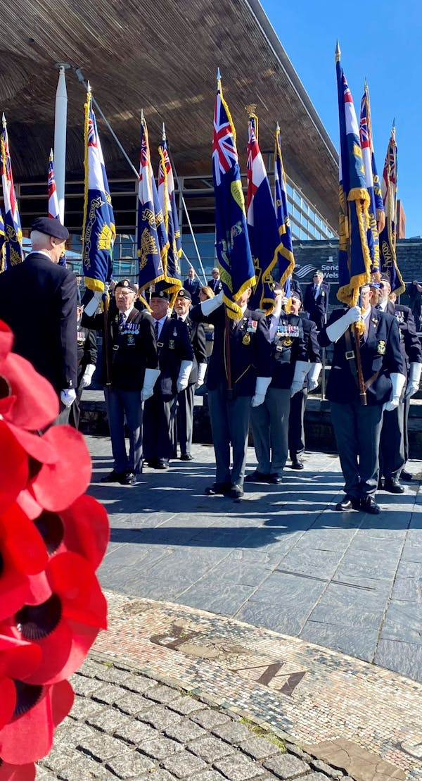

  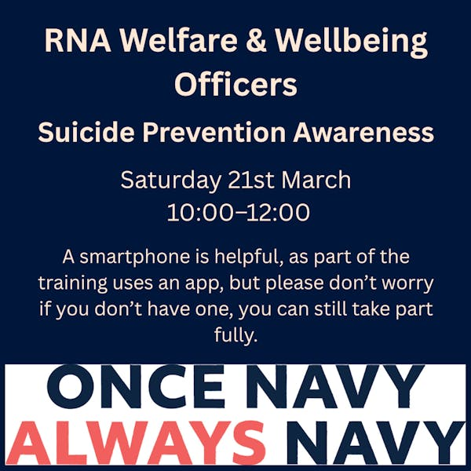
  The Zoom link is HERE
  Please contact RNA Welfare and Wellbeing Co-ordinator Jon Everett for further information if you would like to volunteer to become a Welfare and Wellbeing Officer – wws@rnassoc.org

 |  |  |  |  |  |  |  |  |  |  | 

